

Blazar

**Your name Tariq Horan**

**Your student number N00202437**

Software Project

Develop a PHP shopping website

Year 2 2021-22

DL836 BSc (Hons) in Creative Computing

Table of Contents

1 Introduction 1

2 Business Concept 2

2.1 Business Idea 2

2.2 Business model 2

2.3 Market Research 2

2.4 Marketing/Advertising 2

2.5 Suppliers 2

2.6 Competitors 2

2.7 Employees 2

2.8 Environmental Impact 2

3 Requirements 3

3.1 Introduction 3

3.2 Requirements gathering 3

3.2.1 Similar applications 3

3.2.2 Interviews 3

3.3 Requirements modelling 3

3.3.1 Functional requirements 3

3.3.2 Non-functional requirements 3

3.3.3 Use Case Diagrams 4

3.4 Feasibility 4

4 Web application Design 6

4.1 Layout 6

4.2 Interaction 6

4.3 Colour schemes 6

4.4 Font choices 6

4.5 Wireframes 6

5 Database Design 7

5.1 Description 7

5.2 Business Reporting Requirements 7

5.3 Textual Representation of Data-Set 7

5.4 Business Rules 8

5.5 Entity Relationship Diagram 8

5.6 Tables 9

5.7 Database Dictionary 10

6 System Design/ Architecture Overview 11

6.1 Introduction 11

6.2 Model View Controller 11

6.3 User Authenticaion 11

6.4 Routing 11

6.5 Templating 11

7 Testing 12

7.1 Introduction 12

7.2 Functional Testing 12

7.2.1 Login/Registration 13

7.2.2 Navigation 13

7.2.3 Calculation 13

7.2.4 CRUD 13

7.2.5 Discussion of Functional Testing Results 14

7.3 User Testing 14

7.4 Conclusion 14

8 Project Management 15

8.1 Introduction 15

8.2 Project Phases 15

8.2.1 Requirements 15

8.2.2 Design 15

8.2.3 Implementation 15

8.2.4 Testing 15

8.3 SCRUM Methodology 15

8.4 Project Management Tools 16

8.4.1 Github Project 16

8.4.2 GitHub 16

9 Reflection 17

9.1 Your views on the project 17

9.2 How could the project could be developed further? 17

9.3 Assessment of your learning. 17

9.4 Completing a large software development project 17

9.5 Technical skills 17

9.6 Further competencies and skills 17

10 References 18

# Introduction 1 Introduction

Overall aim

The aim of this software project is to modify and improve fashion trading sites to be more accessible so the site can reach an older demographic.

Application area

Fashion.

Technologies

PHP, MySQL, Bootstrap, CSS, Vanilla

Tools

IDE, phpMyAdmin, Miro

Project management

GitHub

Business Concept

Trading shoes and clothes that are rare or in high demand.

Requirements

The application must allow a user to browse products and if they choose they can buy or sell products.

Design

This project will take inspiration from pre existing websites and will have its own design identity.

Implementation

The project will gradually progress starting from the planning and sketches of the website then later the functionality will be completed.

Testing

The application will be constantly tested while being built and by getting users to complete a task on the site and record results.

Reflection

The finished project will be reviewed on how much functionality is actually working and it ticks all brief requirements.

# 2 Business Concept

## 2.1 Business Idea

An online marketplace where you can buy and sell clothes and shoes. Clothes and shoes that are released are hard to get due to resellers and region restrictions so consumers and sellers from all around the world.

## 2.2 Business model

The business will make money by taking a percentage of the profits made on a sale by a seller eg.15%

## 2.3 Market Research

People of all ages but mainly genZ, people will buy and sell products everyday as there is a constant demand for clothes and shoes, they will use it to sell unwanted or very valuable products. The market is constantly expanding with the demand for high end and limited goods.

## 2.4 Marketing/Advertising

The business will be advertised on social media as the market is predominately young that’s where they can be reached easiest.

## 2.5 Suppliers

The users off the site provide the products as they are selling them through the application.

## 2.6 Competitors

Sites like stockx and goat are the sites that effectively execute this service on their respective applications.

## 2.7 Employees

The project will require a quality control team, an advertising team, a customer service team, and an application admin.

## 2.8 Environmental Impact

The application is all online no physical shop the main environmental impacts the business has is shipping and packaging products.

# Requirements

## Introduction

The purpose of the requirements phase is to allow for developers to work out what the application should be able to do. It is important to understand what the users would like the application to do rather than the developer deciding what is required.

You can write a bit about your project area. Each paragraph has a blank line between it and the previous paragraph

## Requirements gathering

### Similar applications

Look at and document 2 similar applications. Be sure to include the following for each:

* Screen shots
* Descriptions
* Advantages
* Disadvantages

### Interviews

Conduct interviews with 2 or 3 users to find out what the important features for them for the app are. There may be various issues that arise in multiple interviews. These can be grouped together into a number of themes.

## Requirements modelling

### Functional requirements

Create a numbered list of what the application should be able to do. Start with the most important feature.

### Non-functional requirements

These are requirements which if not met do not stop the application from working, but which mean that the application is not working as well as it should. They are usually based on issues such as:

* Usability
* Performance
* Security

### Use Case Diagrams

Consists of actors and use cases. You should document each individual use case.

Delete the following diagram and insert your diagram. Use draw.io

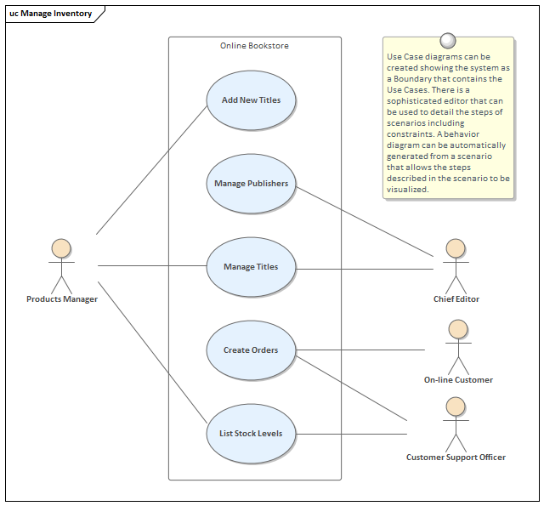

## Feasibility

This section describes which technologies are planned to be used in the development of the application. It then explains if there are any issues in terms of the technical feasibility of the project, for example, if there are two different types of software which may have compatibility issues.

# Web application Design

## Layout

Describe the layout of your web application. Does this depend on a framework like bootstrap? Is it repsonsive?

## Interaction

What are the navigation elements, form elements. How does the user interact with the application?

## Colour schemes

Describe the colour palette that you will use consistently across the web application

## Font choices

Specify the fonts that you will use for different types of text. Include samples for paragraph text, headings and bold and italicised text.

## Wireframes

Describe how to navigate from one page to the next by adding an diagram of the different screens and what the main functionality is.

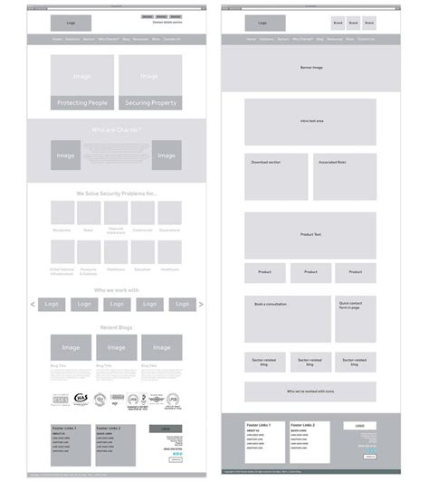

# Database Design

## Description

A company has a website that sells video games for different consoles. They would need a database for all their games and order places. For each order place, they would need games bought, total price, date of the order, and how long it will take to deliver. The database needs to keep track of all games that are being sold. Customers will have to input their information when registering an account. Customers will also have to input their card details when making a payment for their order.

## Business Reporting Requirements

Substitute in here the information the users of your application will want to be able to view.

1. Organisers need to be able to create, read, update, and delete: festivals, stages, shows, performers, and genres.
2. Users will need to be able to find all festivals ordered by their start date.
3. Users may want to find a festival by a specific start date.
4. Users need to find all festivals using a list of genres.
5. Users need to find the stage for a specific show.
6. Users need to find the shows using a performers name.
7. Performers may need to find the list of festival contacts.
8. Users need to find festivals by location and the location needs to be displayed on a Google Map
9. User may need to find festivals by city
10. Users need to find stages within a festival by the stage’s location
11. Organisers need to display a list of employees that are assigned to a specific festival

## Textual Representation of Data-Set

Substitute in here the tables for your database

**FESTIVAL** (title, description, latitude, longitude, city, start_date, end_date, image_id)

**PERFORMER** (title, description, contact_email, contact_phone, image_id)

**GENRE** (title, description)

**IMAGE** (id, filename)

**SHOW** (date, start_time, end_time, performer_id, stage_id)

**STAGE** (title, description, location, festival_id, image_id)

**GENRE**_**PERFORMER** (id, genre_id, performer_id)

**EMPLOYEE** (name, phone, email)

**FESTIVAL_EMPLOYEE** (employee_id, festival_id, role)

## Business Rules

Substitute in here the business rules for your database

• A **Festival** has many **Stages**.

• A **Stage** belongs to one **Festival**.

• A **Stage** hosts many **Shows**.

• A **Show** is performed on one **Stage**.

• A **Performer** can perform in many **Shows**.

• A **Show** is performed by one **Performer**.

• A **Performer** can have many **Genres**.

• A **Genre** can belong to many **Performers**.

• A **Performer** can have a single **Image**.

• A **Festival** can have a single **Image**.

• A **Stage** can have a single **Image**.

• An **Image** can be associated with a **Performer**, **Festival**, or **Stage**

• A **Festival** can have many **Employees** associated with it

• An **Employee** can be assigned to one **Festival** at a time

## Entity Relationship Diagram

Substitute in here your ERD from draw.io

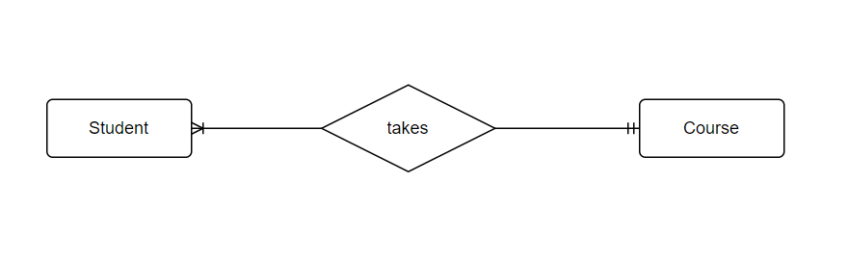

## Tables

Substitute in here your tables and the relationships between tables from draw.io in the format you used in DBMS with Mohammed.

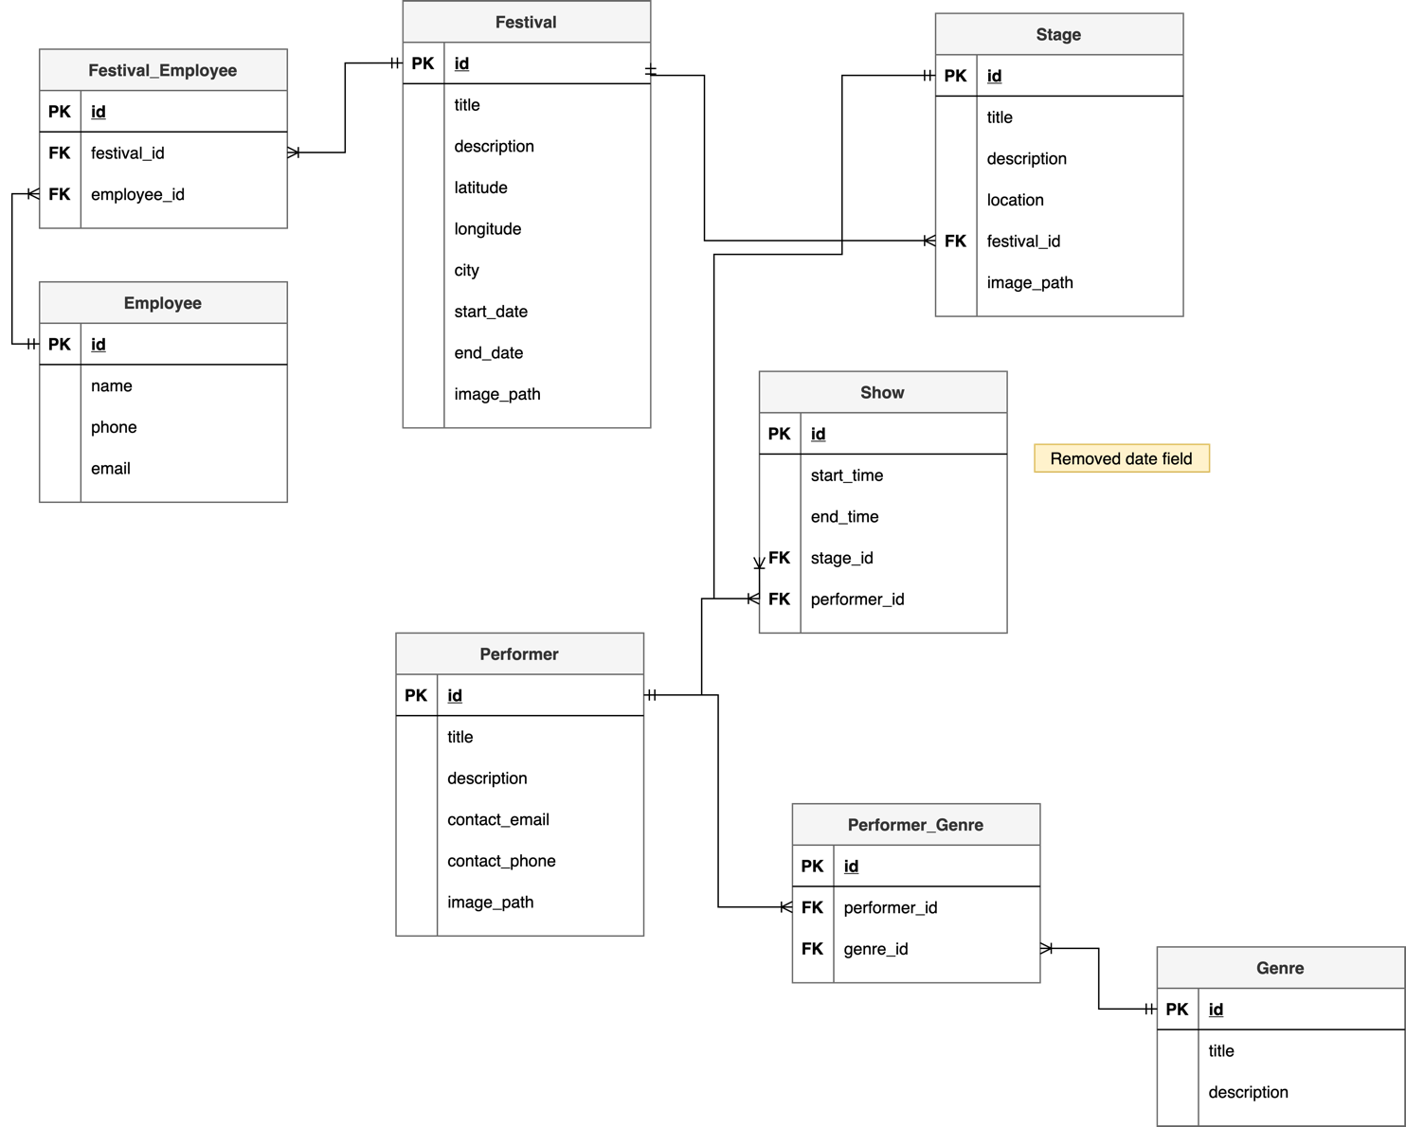

## Database Dictionary

|  |  |  |  |  |  |  |
| --- | --- | --- | --- | --- | --- | --- |
| Table | Attribute | Datatype | Range | Required | PK/FK | FK Ref Table |
|  |  |  |  |  |  |  |
|  |  |  |  |  |  |  |
|  |  |  |  |  |  |  |
|  |  |  |  |  |  |  |
|  |  |  |  |  |  |  |

# System Design/ Architecture Overview

* 1. Introduction

This section will describe the internal functionality of the web framework that you have chosed for the implementation. Add further sections if required by the specification of your web application

* 1. Model View Controller

Explain the follows a model-view-controller design pattern and how it is implemented in your web application.

* 1. User Authenticaion

Explain how user authentication is implemented in the web application framework.

* 1. Routing

Describe the routes that were defined in the web application

* 1. Templating

Describe the templating engine and how it was used to configure/ style the web application.

Add a sequence diagram in this section and other diagrams that illustrate the architecture clearly.

# Testing

* 1. Introduction

This chapter describes the testing that has been undertaken for the application. This chapter is presented in two sections:

1. Functional Testing
2. User Testing

Functional testing is a type of software testing whereby the system is tested against the functional requirements. The app is tested by looking to see if the actual output for a given input corresponds with the expected output. The tests should be based on the requirements for the app. The results of functional testing can indicate if a piece of software is functional and working, but not if the software is easy to use.

User testing looks to see if a piece of software is easy and intuitive for the user.

* 1. Functional Testing

This section describes the functional tests which were carried out on the app. These functional tests can be categorised as: (whatever is relevant to your app)

Login/Registration

Navigation

Calculation

CRUD

Functional testing generally uses a Black Box Testing technique which means that the internal logic of the system being tested is not of interest to the tester. The tester is only interested in whether the actual output agrees with the expected output.

* + 1. Login/Registration

|  |  |  |  |  |  |
| --- | --- | --- | --- | --- | --- |
| Test No | Description of test case | Input | Expected Output | Actual Output | Comment |
| 1 | User logs in with a valid email and password | [example@blazar.ie](mailto:example@blazar.ie)  ********** | You are now logged in | You are now logged in | Pass |
| 2 | User enters an unknown email and/or password | [unknown@blazar.ie](mailto:unknown@blazar.ie)  ********** | These credentials do not match our records. | These credentials do not match our records. | Pass |
| 3 | User enters an email without the @ sign with a valid password | Example.ie  ********** | Please include a @ the email address example.ie is missing a @ | Please include a @ the email address example.ie is missing a @ | Pass |

* + 1. Navigation

|  |  |  |  |  |  |
| --- | --- | --- | --- | --- | --- |
| Test No | Description of test case | Input | Expected Output | Actual Output | Comment |
| 1 | Click home button | http://127.0.0.1:8000/ | Blazar homepage | Blazar  homepage | Pass |
| 2 | Click browse button | http://127.0.0.1:8000/user/shoes | Blazar products page | Blazar products page | Pass |
| 3 | Click view product | <http://127.0.0.1:8000/user/shoes/> {id} | Blazar product view page | Blazar product view page | Pass |

* + 1. Calculation

|  |  |  |  |  |  |
| --- | --- | --- | --- | --- | --- |
| Test No | Description of test case | Input | Expected Output | Actual Output | Comment |
| 1 | User buying product, shipping calculated |  | Shipping added to product price | Shipping added to product price |  |
| 2 | User selling product, selling fees calculated |  | Fees subtracted from product selling | Fees subtracted from product selling |  |
|  |  |  |  |  |  |

* + 1. CRUD

|  |  |  |  |  |  |
| --- | --- | --- | --- | --- | --- |
| Test No | Description of test case | Input | Expected Output | Actual Output | Comment |
| 1 | Admin edits product in the database | http://127.0.0.1:8000/admin/shoes/1/edit | Redirected to http://127.0.0.1:8000/admin/shoes | Redirected to http://127.0.0.1:8000/admin/shoes | Pass |
| 2 | Admin deleted product from the database | http://127.0.0.1:8000/admin/shoes | Product is deleted | Product is deleted | Pass |
| 3 | Admin adds product to the database | http://127.0.0.1:8000/admin/shoes/create | Product is added to database | Product is added to the database | Pass |

### Discussion of Functional Testing Results

The results were positive anything that failed was a quick fix because they were minor syntax errors.

* 1. User Testing
  2. Conclusion

The results were good the admin has crud functionality over the application as intended. The next thing to do is to give the user create functionality so the can create a product to be added to the database.

# Project Management

## Introduction

This chapter describes how the project was managed. It shows the phases of the project, going from the project idea through the requirements gathering, the specification for the project, the design, implementation and testing phases for the project. It also discusses GitHub as a tool which assist in project management.

## Project Phases

In this section, describe each of the following project phases. Explain any issues which arose for each of the phases.

### Requirements

### Design

### Implementation

### Testing

## SCRUM Methodology

Sprints

## Project Management Tools

### Github Project

Description

Include screen shots

How it worked in practice

### GitHub

Description

How it is used

How it worked in practice

# Reflection

## Your views on the project

Describe how you feel the project went from your perspective.

## How could the project could be developed further?

## Assessment of your learning.

Critically assess your learning. List what skills and competencies you have learned developed in this Continuous Assessment.

List which part of the project would need further development and itemize where you feel you have not satisfactorily completed the continuous assessment.

## Completing a large software development project

Describe what you have learnt from the project, from the point of view of completing a large software development project.

## Technical skills

Describe what you have learnt from the project, from a technical skills viewpoint.

## Further competencies and skills

Describe any extra competencies and skills that would help you with your development in the work place.

# References

Add a list of references that you used to complete the project.

The Department of Technology and Psychology in IADT uses APA 7th referencing style.

Use alphabetical order for your references.

This site gives details about how to cite websites using APA:

https://www.wikihow.com/Cite-a-Website-in-APA

The following is a useful site for creating citations for APA for websites.

<http://www.citationmachine.net/apa/cite-a-website>

You can also use the Referencing tab within Microsoft Word to enter reference information manually. Word then creates an APA style reference.